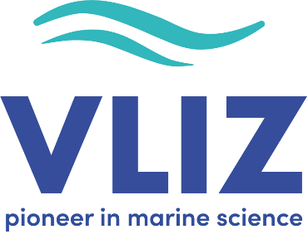

APPLICATION FORM

Brilliant Marine Research Idea 2025
Application for the ‘Brilliant Marine Research Idea’ grants is only valid if the following documents are submitted no later than 17 January 2025:
- This application form (fully completed, max. 4 pages including this front page)
- Your cv
- A consent form of your supervisor (free format)
- Optional: a copy of your PhD/postdoc proposal, to prove the add-on value of your BMRI proposal
- Only for predocs in the South
  - A recommendation letter of the scientist with whom you are connected at a Flemish Marine Research Group, a Flemish university or a Flemish university college (free format)
  - A copy of your international master’s degree from a Flemish university or proof of your doctoral grant, half awarded by a Flemish Marine Research Group or university combined with the financing of the other half by a partner institution or university in the South.
All documents must be delivered by email to filantropie@vliz.be with the subject ‘Proposal for a Brilliant Marine Research Idea 2025 (PhD student/junior postdoc/predoc South)’.
Please select the grant for which you want to apply:
☐ BMRI grant for PhD students
☐ BMRI grant for junior postdoctoral researcher
☐ BMRI grant for predoc in the South

General information
Title of the idea
Title of the PhD / postdoc research
Name of the applicant
Date of birth of the applicant
Year of obtaining the master’s degree
Name of the supervisor
University or university college

Brilliant Marine Research Idea & activities
Explain how the idea for a BMRI rose within your (PhD) research, including a short state of the art of the research topic and the objective you aim to achieve. Emphasize why your BMRI research topic is an out of the box idea, an additional research topic that was initially not foreseen in the PhD.
max. 40 lines (font: Calibri, font size: 10)

Describe the chosen activities and demonstrate how they will contribute to achieving the defined objective of your BMRI grant within the proposed timeframe (1 year).
max. 40 lines (font: Calibri, font size: 10)

References
max. 25 lines (font: Calibri, font size: 10)

Budget
Indicate why the idea cannot be executed without the funding provided by the grant for a ‘Brilliant Marine Research Idea’ (max. 5.000 EUR).
max. 15 lines (font: Calibri, font size: 10)

Describe in detail how the requested fund (max. 5.000 EUR) will be spent within the implementation period (1 March 2025 until 28 February 2026). Be as specific as possible. Take the following in account: the grant includes all possible university/institute ‘overhead’ or other costs, i.e. no additional will be accepted (no personnel costs, no conference fees, no reimbursement of the use of existing lab infrastructure within your research group or department; travel costs cannot amount to more than 50% of the grant).
max. 25 lines (font: Calibri, font size: 10)

