COAST RELATED TOPICS IN FP7 ENVIRONMENT PROGRAMME (FIRST CALL) OF INTEREST FOR ENCORA

Excerpt of the workprogramme ENVIRONMENT-COOPERATION: http://cordis.europa.eu/fp7/dc/index.cfm?fuseaction=UserSite.CooperationDetailsCallPage&call_id=6

The following topic offers an excellent opportunity to involve other FP6 projects (Marbef, Floodsite, Spicosa, ..) in the development of Coastal Wiki, as a means to disseminate and provide easy access to all information of potential interest to the marine stakeholder community (public and private)

The following topic is related to ENCORA Theme 6 Effect of Development and Use on Eco-morphology and Coastal Habitats

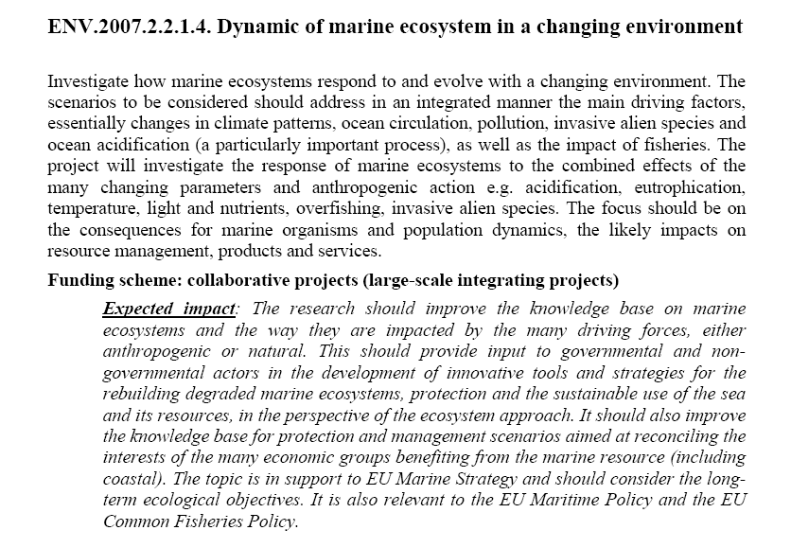
The following is a selection of topics that may be interesting for ENCORA partners or for members of the national networks, thematic networks and affiliated networks.

ENCORA may offer assistance to find partners for the establishment of consortia.

