Position Announcement

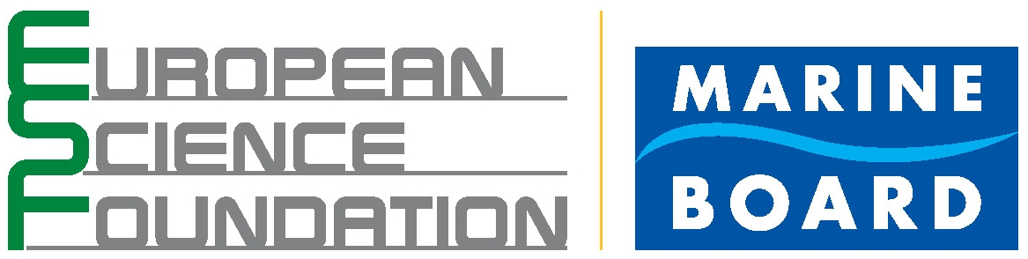 | Marine Board - ESF invites application for the position of  Junior Science Officer  Marine Board Secretariat  Location – Oostende (Belgium)

Mission & Success Factors of the Position

Supporting the Marine Board Executive Secretary (Head of Secretariat) in developing a partnership with Marine Board Member Organisations so that the Marine Board becomes the preferred actor of choice on behalf of its Member Organisations.

The work will include support to activities funded by the European Commission via the MarinERA project, and other contracts.

The candidate should demonstrate abilities to:
- assist in the mobilisation and support activities and strategies on behalf of the Marine Board Member Organisations through promoting research collaboration in an inter- and multi-disciplinary environment across Europe;
- assist in the development of science policy and strategy;
- if necessary, to represent the Marine Board and improve its visibility to the European research community.

The position will involve:
- Assisting the Marine Board Executive Secretary in supporting the Marine Board’s strategic and policy activities and providing, in a timely manner, advance quality papers, minutes and reports;
- Ensuring compliance with external contracts through full and timely reporting, liaising, in coordination with ESF Administration and Finance, with external partners as appropriate and drafting proposals for future support;
- Taking responsibility for the adherence to budgets of specific activities in compliance with ESF Financial Rules and Delegated Financial Authority and providing necessary information to Administration and Finance allowing the regular presentation of financial reports;
- Representing the Marine Board, on behalf of the Executive Secretary, at external meetings, when necessary;
- Publicising and informing the research community by taking responsibility for science communication (material for hard copy publication, and the Web) and liaising with the ESF Communications Unit;
- Maintaining an up-to-date awareness of relevant scientific and research policy developments;

Profile and Competences required

The successful jobholder should demonstrate the following competences:

Specific competences
- Post-graduate with Master’s qualifications and preferably with a further 1-2 years research experience in a relevant science area;
- High standard of spoken and written English, with a working knowledge of another European language being an advantage;
- Ability to draft under supervision concise and clear science-based documents;
- Good working knowledge of MS Office systems and of electronic databases and Web sites.

Inter-personal competences:
- Action-orientated, responsible and self-managed, creative and willing to take initiatives, and continuously improvement-minded;
- Strong inter-personal and excellent communication skills within a multi-national context, including discretion, diplomacy and tolerance;
- Good presentational skills;
- Good organisational skills;
- Transparency in working and a team-orientated work ethic;
- Commitment to deliver on allocated tasks and respond in a timely manner to deadlines;
- Positive and constructive attitude;
- Capable of demonstrating the ESF’s values: Excellence, Openness, Responsiveness, Pan-European approach, Ethical Awareness and Human Values.

Employment conditions

- The full time position is offered for a short term contract preferably starting Q4 2007 until 31 October 2008.
- The place of work is Oostende (Belgium) and the job will involve some travel.
- The salary level will be based on experience and qualifications of the successful candidate and will follow ESF terms and conditions.
- Please send your application by 4 July 2007 to ESF, Human Resources Unit
1 quai Lezay-Marnésia, BP 90015, F-67080 Strasbourg or to jobs@esf.org quoting the following reference identifier MB-JSO
- Interviews will be held in Brussels on 13 July 2007.

Further details at www.esf.org

